**Solving System of Linear Equations**

Systems of equations are a collection of one or more relationships between two or more variables. A solution/s to such a system of equations is values of variables that satisfy all equations. In this article, we’ll explore how to solve systems of linear equations with two variables.

**Substitution**

Substitution involves replacing one variable in terms of another to yield an equation that consists of a single variable.

Consider the following system of linear equations:

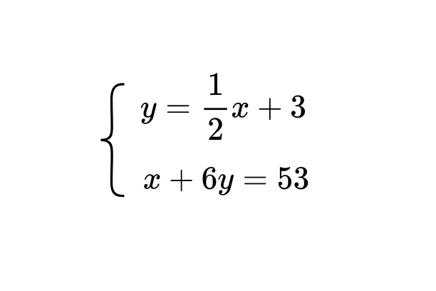

We can replace y in the 2nd equation using the expression for y in the 1st equation.

$2x + 6(\frac{1}{2}x +3) = 53$

Now the above equation can be simplified, and solved to determine the value of x.

$2x + 3x + 18 = 53$

$5x + 18 =53$

$5x = 45$

$x = 9$

After determining the value of x, it can be substituted in any one of the equations in the system to determine the value of y.

Let’s substitute x =9 in the first equation:

y = $\frac{1}{2}×9 +3$

$y = \frac{15}{2}$

Hence the solution to the system of equations is x = 9 and y = $\frac{15}{2}$.

**Elimination**

Another approach to solving a system of equations is through elimination. This method involves adding or subtracting equations systematically to eliminate one of the variables. The steps to be followed in solving the following system are given below:

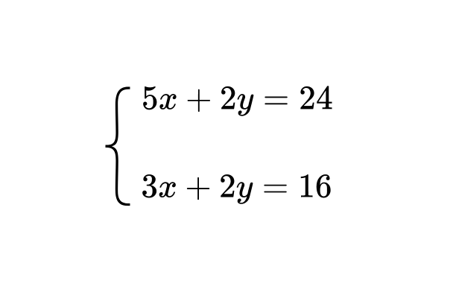

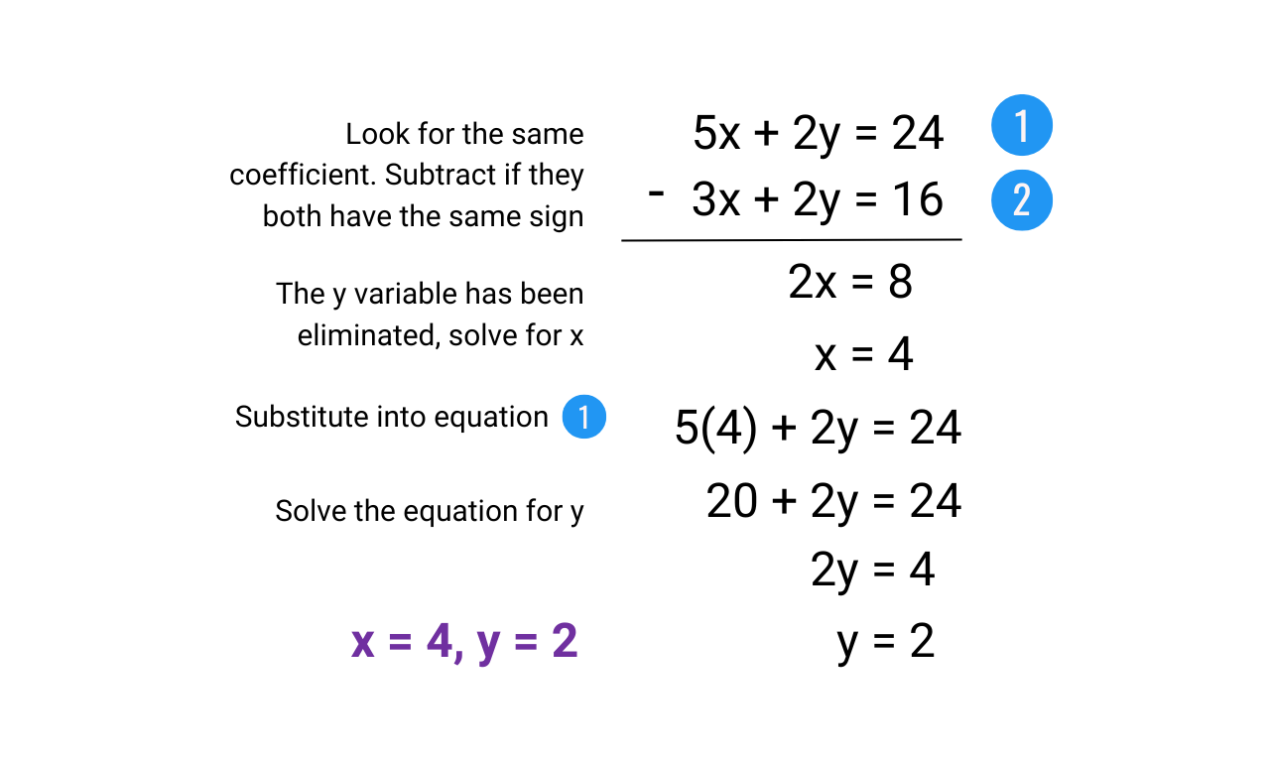

Sometimes the original forms of the equations may not have variables with identical coefficients. The following system is one such example.

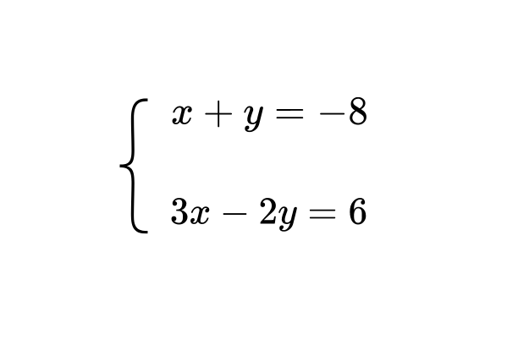

In this case, we can select any variable to eliminate. To eliminate a variable we have to rewrite the equations so that the coefficients of the selected variable in both equations are identical.

Let’s try to eliminate the variable x. In the first equation, the coefficient of x is 1, and in the second it is 3. We can multiply both sides of the first equation by 3, to match the coefficients of x.

The new equation would be:

$3x + 3y = -24 -(1')$

To eliminate the variable x, we can subtract the 2nd equation from the modified equation (1’)

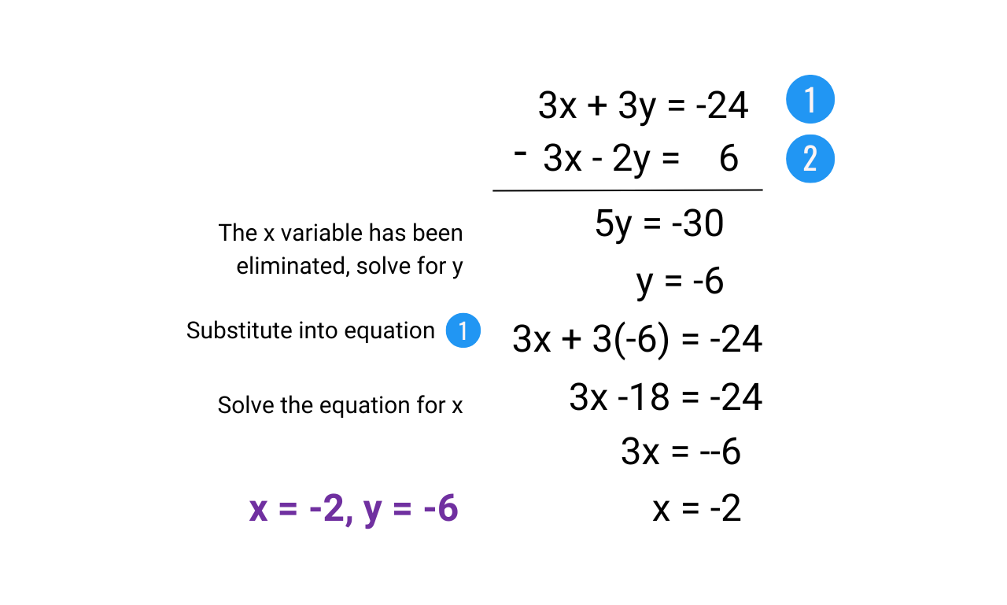

The solution to the system of equations is x = -2 and y = -6.

**Graphical Approach**

The graphical approach is a visual method of solving systems of equations. The solutions of simultaneous equations with two unknown variables correspond to the point of intersection of their graphs.

Let’s use the graphical approach to solve the following system of equations:

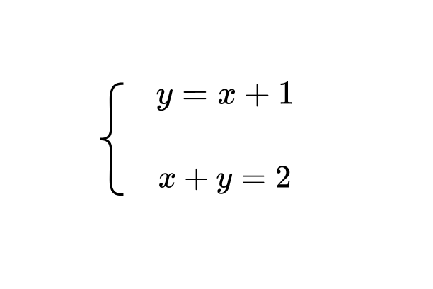

Both the equations in the system are linear equations, hence they are represented as straight lines of a cartesian plane. Once we plot the graphs of the two equations, we can obtain the solution to the system.

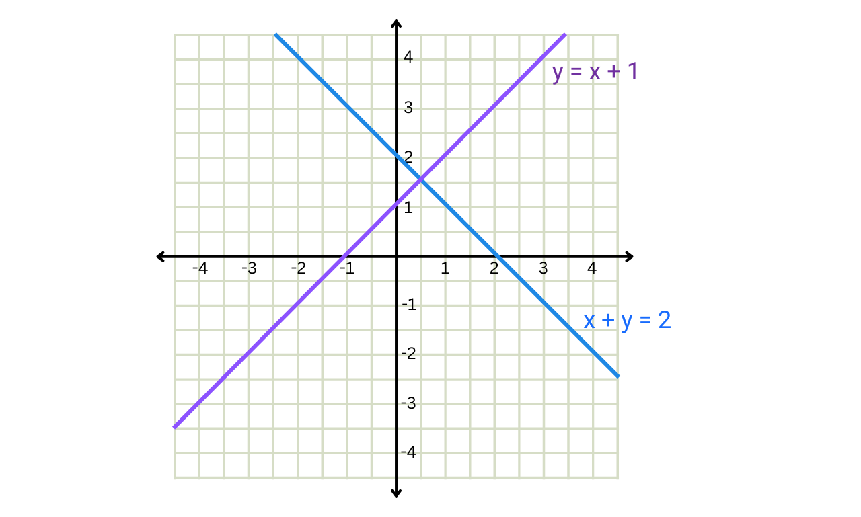

The coordinates of the point of intersection of the two lines are (0.5,1). Hence the solution to the system of equations is x = 0.5 and y = 1.

**Inconsistent systems**

Not all systems of equations can be solved. Inconsistent systems are those that do not have any solutions. To intuitively understand why some pairs of equations might not have a solution, consider the graphical representation of their solutions.

Imagine a system of equations where the two lines are parallel. Since parallel lines never intersect, there is no point that satisfies both equations simultaneously. Therefore, this system has no solution.

Algebraically, you can determine if a system of two equations is inconsistent by comparing the slopes of the lines. If the slopes are equal but the y-intercepts are different, the lines are parallel and the system is inconsistent.